Albert Waterman
CS 499 Enhancement 3

For my database enhancement, I used my CS 340 Animal Shelter Dashboard. This artifact was originally created using Python, Dash, and MongoDB with data from the Austin Animal Center. The dashboard already allowed users to view animal records, filter animals by rescue category, see breed information in a chart, and view animal locations on a map. I selected this artifact again because MongoDB was already a major part of the project, which gave me a good starting point for improving the way the application stores, retrieves, validates, and manages data.
The main goal of this enhancement was to improve the database features without changing the overall style of my original dashboard. I added a database management section that allows the user to add, update, and delete animal records directly from the dashboard. When a table row is selected, the animal information is loaded into the input fields so the user can update or delete that specific record. I also added input validation in the service layer. The program removes extra spaces, checks required values, converts number fields, and prevents duplicate animal IDs from being added. These changes make the dashboard more useful because users can now manage records instead of only viewing them. The service layer handles the validation and application logic, while the repository layer performs the MongoDB operations.
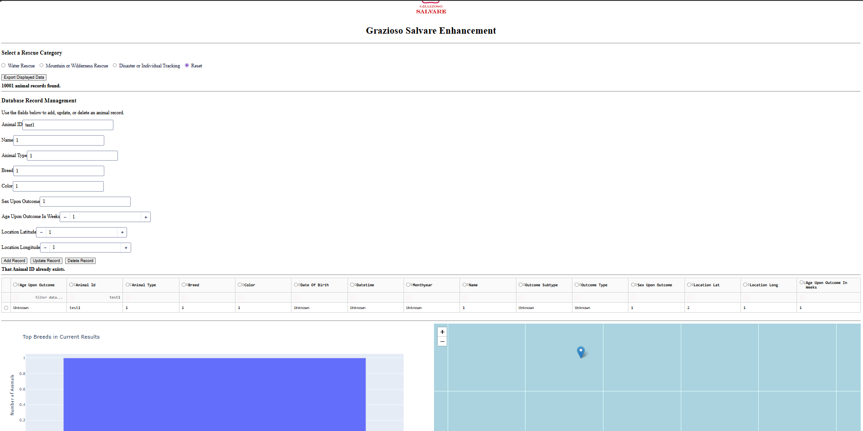
I also improved the database security by removing the MongoDB connection information from the main source code. The application now loads the MongoDB URI, database name, and collection name from an environment file. This makes the project safer because connection information does not have to be hard-coded throughout the application. The repository also uses error handling so the dashboard can display a simple message instead of showing detailed database information to the user.
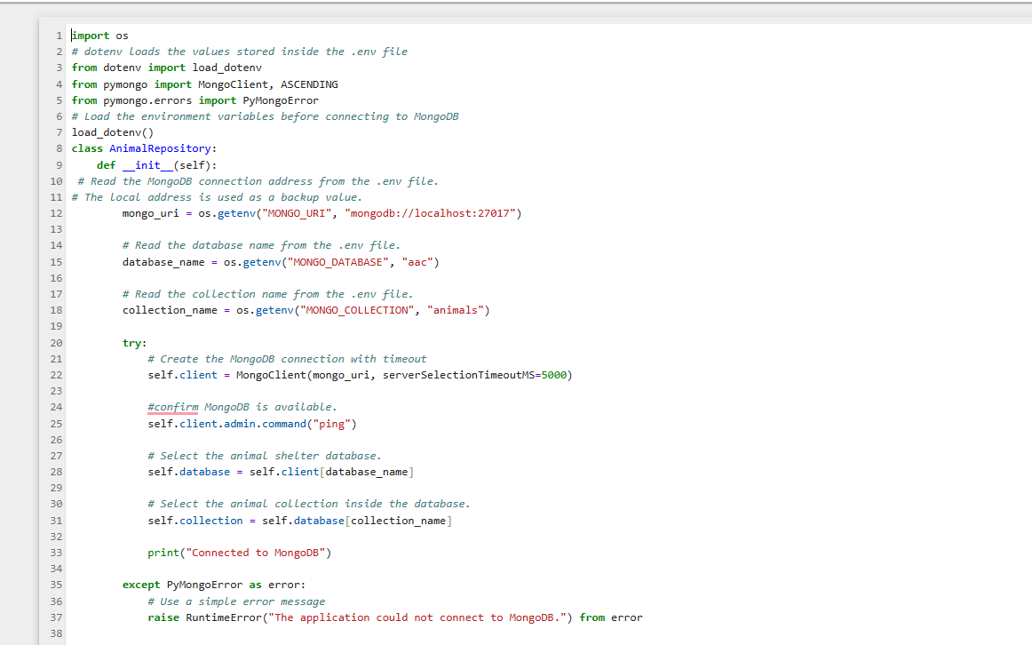
Another part of the enhancement was adding MongoDB schema validation. The validation requires fields such as the animal ID, animal type, breed, and sex upon outcome. It also checks that the age and location fields use number data types. This helps prevent incomplete or incorrect information from being added to the database. I used a moderate validation level so the rules apply to new records and future updates without forcing me to change every older record already stored in the collection.
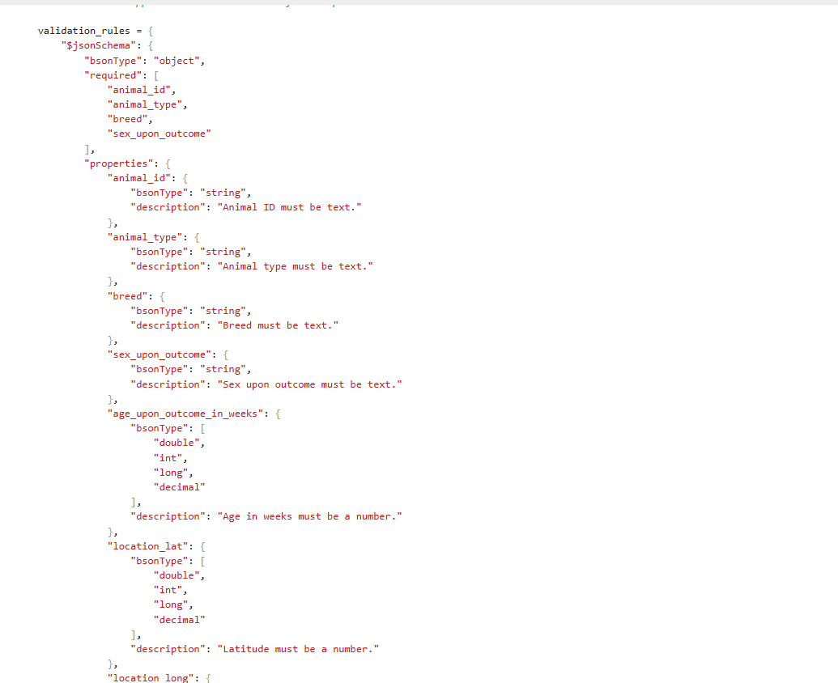
I added indexes for fields that are commonly used when searching and filtering the animal records. These fields include animal type, breed, outcome type, and sex upon outcome. Before creating an index, the program checks the indexes that already exist so it does not attempt to create duplicates. The separate database setup file runs the index and schema validation methods and confirms whether the setup was completed. This improves the project because indexes can help MongoDB find matching records more efficiently as the amount of data grows.
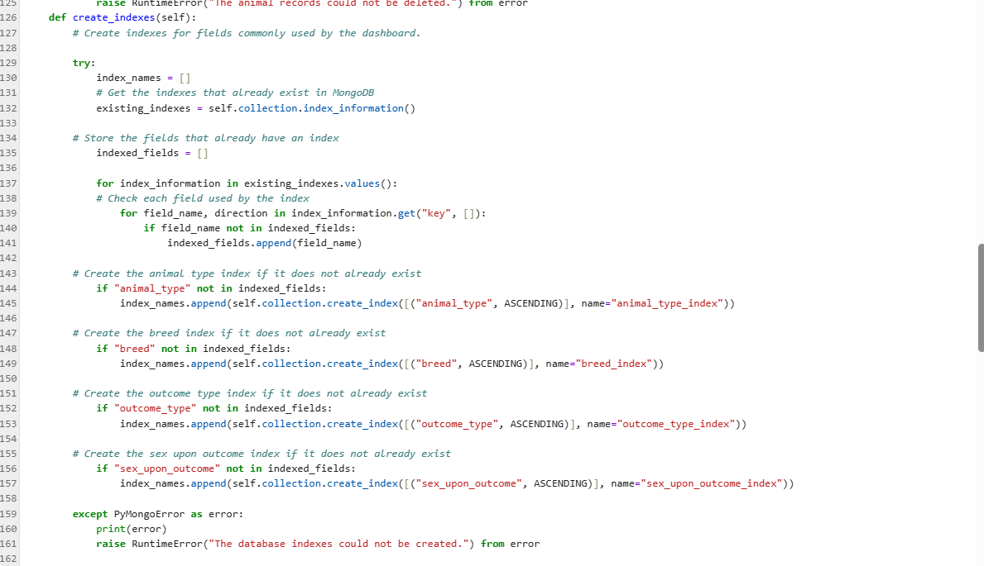
I also added an aggregation pipeline that allows MongoDB to create a summary of the most common breeds. The pipeline uses $match to apply the selected rescue filter, $group to count each breed, $sort to place the highest totals first, and $limit to return the ten most common breeds. This allows more of the data processing to happen inside MongoDB instead of retrieving every record and completing all calculations inside Python.
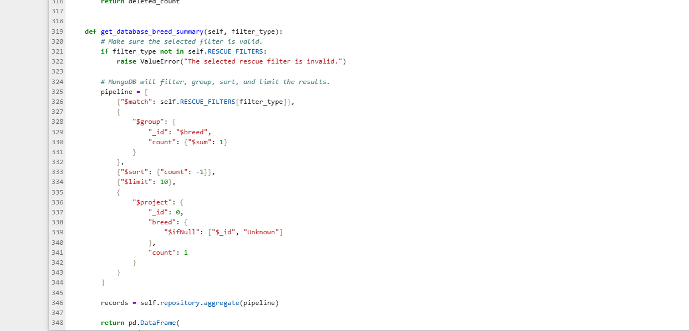
One challenge I faced was creating the indexes because some indexes already existed in MongoDB under different names. My original code tried to create the same index again, which caused an issue when trying to run. I resolved this by retrieving the existing index information and checking which fields already had indexes before creating new ones. Another challenge was adding the database management controls without making the dashboard feel like a completely different project. I wanted the enhancement to still look like code I had originally written. I kept the same basic layout, comments, naming style, table, chart, map, and filter controls. I placed the database section between the rescue filters and the table so it was easy to find while still fitting into the existing dashboard. I also added a refresh value so the table automatically reloads after a record is added, updated, or deleted.
This enhancement supports Course Outcome 1 because the improved filtering, reporting, and database management features help users work with animal information and make decisions. It supports Course Outcome 3 because I evaluated different database techniques, including indexes, aggregation, validation, and processing data in MongoDB instead of only in Python. It supports Course Outcome 4 because I used Python, Dash, MongoDB, environment variables, aggregation pipelines, and database management methods to create a working solution. It also supports Course Outcome 5 because I removed hard-coded connection settings, validated user input, applied database validation rules, and used error handling to protect database information.
I improved the artifact by making it more complete and professional while still keeping the original design. The first version mainly retrieved and displayed records. The enhanced version now supports creating, reading, updating, and deleting records, safer database access, schema validation, indexing, and database aggregation. This project helped me better understand how the dashboard, service layer, repository layer, and MongoDB database work together as one application.

References:
Aggregation stages - database manual - mongodb docs. Aggregation Stages - Database Manual - MongoDB Docs. (n.d.). https://www.mongodb.com/docs/manual/reference/mql/aggregation-stages
Create indexes to support your queries - database manual - mongodb docs. Create Indexes to Support Your Queries - Database Manual - MongoDB Docs. (n.d.). https://www.mongodb.com/docs/manual/data-modeling/schema-design-process/create-indexes

Specify validation level for existing documents - database manual - mongodb docs. Specify Validation Level for Existing Documents - Database Manual - MongoDB Docs. (n.d.). https://www.mongodb.com/docs/manual/core/schema-validation/specify-validation-level

